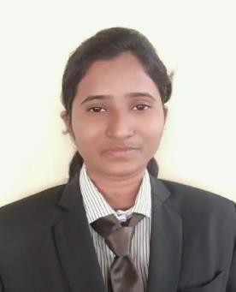

Ashwini Diliprao Panchal

**E-mai**[**l:** ashwinidpanchal18@gmail.com](mailto:ashwinidpanchal18@gmail.com) **Mobile:** 7249652747

**Linkedln id:** <https://www.linkedin.com/in/ashwini-panchal-16798617a>

# Career Objective:

To pursue a challenging career in leading and progressive research organization offering opportunities for utilizing my skills towards the growth of the organization.

# Academic Details:

|  |  |  |  |  |
| --- | --- | --- | --- | --- |
| **Course** | **Institution** | **University**  **/ Board** | **Year** | **Percent age/**  **CGPA** |
| B.E.(Electronics & Telecommunication Engineering) | G.H. Raisoni College of Engineering, Nagpur | RTMNU | 2020 | 8.41 |
| H.S.C. | Yeshwant Mahavidyalay, Nanded | MSBSHSE | 2015 | 56.00% |
| S.S.C | Lt Vishwanathrao Nalge High School, Loha | MSBSHSE | 2013 | 86.73% |

**Technical Skills:**

* Programming Languages: C Language, Core Java
* Tools: Dev C++, JDK, Eclipse
* Database: DBMS, SQL
* Operating System: Windows, Mac

# Internship Experience:



* BSNL , Nanded (4 Weeks)
* Kwality Photonics, Hyderabad (6 Months)

# Social Service:

* “Aashish Sevabhavi Sanstha” (NGO), Kinwat

# Projects Undertaken:

1. **Smart Industrial Control System**
   * **Technologies used:** Arduino Microcontroller
   * **Description:** This project aims to implement a simple industrial system on a small scale, it is an open source platform which perform sequential operation using Arduino Microcontroller.

# Certification:

* Cloud Core Under IBM Developer Skills Network
* National Certificate in Modular Employable skills (DTP & Print Publishing Assistant) Under Skill Development Initiative Scheme

# Strengths:

* Practical Approach Toward Work
* Self Motivated
* Enthusiasm

**Interests:**

* Yoga
* Painting

# Personal details:

* **Date of birth:**18/08/1997
* **Address:** Yashdayini Niwas, Shivkalyan Nagar, Loha, Dist. Nanded
* **Languages known:** English, Hindi, Marathi